Managing Stress in Challenging Times:
Using the Enneagram to Access Inner and Outer Resources

A Saturday Enneagram Workshop
--with Carl Marsak, MA

Sponsored by The Enneagram Center of Southern Oregon
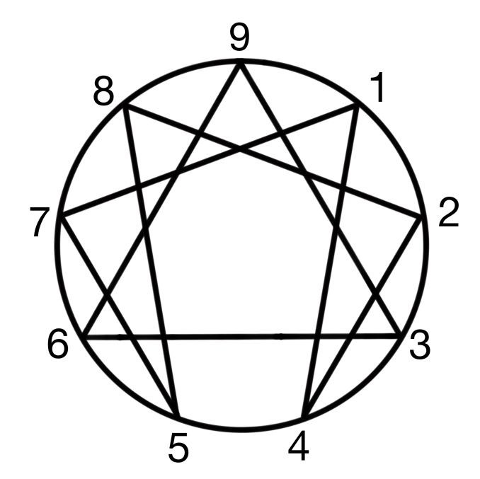
“Sacred Psychology is the ancient art of psycho-spiritual alchemy.
It transforms the 'lead' of the psyche into the 'gold' of integration and Higher Consciousness.”
--Helen Palmer

When: Sept. 26th, 2026, 10 - 5 pm
Where: Peace House, 543 S. Mountain Ave., Ashland
Cost: $75.00 – $95.00 sliding scale.
Pre-registration by email is required. No deposit necessary.
Note: lunch is not included.

How do the 9 Enneagram Types react and respond to the stresses and strains of daily life, including those generated by the difficult political, cultural and environmental times we are all going through in 2026? What are the differences between bad stress (distress) and good stress (eustress), according to the pioneering work of Hans Selye, and his theory of the General Adaption Syndrome? What are the five primary stress mechanisms that the human body-mind naturally activates when facing a perceived threat: fight, flight, freeze, fawn and flop? Finally, what are the salient differences between stress and trauma? Inquiring minds and hearts want to know!
Enneagram theory says that each of the 9 Types has a Basic Fear, Basic Desire and a Defense Mechanism built into their psychic structure, as well as habitual emotional, mental and physical patterns of behavior, all of which tend to become automatically activated with significant stress. In addition, each Type has an associated Passion or Vice that gets quickly triggered (Anger, Pride, Vanity, Envy, Avarice, Fear, Gluttony, Lust and Sloth), as well as corresponding Ego Ideals and Avoidances. In short, “we go on automatic,” and get triggered into stress reactions in characteristic and highly predictable ways. We will pay special attention to the dynamic movements along the Inner Lines according to Type. How do our characteristic traits and behaviors change under conditions of stress and security? All of this is important because when we are chronically stressed it becomes harder to access, embody and express the spiritual or depth dimension of the Enneagram and our own Type, with its corresponding Virtues, Holy Ideas, Healthy Instincts and Essential Qualities.
The good news is with targeted self-observation leading to increased self-awareness, a good understanding of Type structure and relevant psychodynamics, and Enneagram-related spiritual practices, these patterns can be examined and changed. Each Type can learn to relax through his or her personal reactivity in order to gain access to Type-specific psychological capacities, behavioral modifications and spiritual gifts. These can become powerful coping strategies in the short term, and methods of psychological growth and spiritual development in the long term. Importantly, we can also gain insights about, and develop compassionate understanding of, the strength and challenges of the other 8 Types. This helps build bridges of understanding between individuals and within communities, which in turn can prevent and/or reduce stress levels before they become unmanageable and cause a range of health problems. The ultimate goal is to both manage and recover from stress, and, if possible, prevent it from occurring in the first place.
This workshop includes guided meditations, teachings, handouts, breakout groups, time for class discussion, Q & C and, if there are willing participants, one or two short Type Panels. This workshop is mostly on an intermediate level (although beginners are certainly welcome!), and assumes that participants already know their own dominant Type. I will probably not have much time in a group setting to help participants find and explore their own Type. Therefore, it would be useful for beginners to do some advance research on the 9 Types and try to discover their place on the sacred symbol before joining us. For more personalized work I offer both in-person and Zoom Typing Interviews and Mentoring Sessions. For more info about these services, including the fee schedule, please visit enneagramoregon.com, or call or text at: (415) 297-3174.
Schedule:
10 - 11:30 Introductions, Guided Meditation, Teachings, Class Discussion
11:30 - 11:45 Break
11:45 - 1:00 Teachings, Breakout Groups, Q&C
1:00- 2:15 Lunch
2:15 - 3:45 Guided Meditation, Teachings, Class Discussion, Breakout Groups
3:45 – 4:00 Break
4:00 - 5:00 Final Teachings, Type Panels, Concluding Remarks and Takeaways!
If you plan on attending, please try to be with us for the entire day. This helps create a shared and safe space for mutual support and group learning. If you RSVP and then later decide you can't attend, please let me know as soon as possible so I can offer your place to someone else.
Please note that studying and practicing the Enneagram is not a substitute for medical treatment, psychotherapy or spiritual direction. If you are suffering from a serious health condition result, I encourage you to find and make use of appropriate resources outside the group.
For information about Carl and The Enneagram Center of Southern Oregon visit: enneagramoregon.com. For additional useful materials on the Enneagram explore: narrativeenneagram.org, and internationalenneagram.org. For questions about this weekend and to pre-register, email Carl at: cmarsak@gmail.com. See you then and there!
--Carl
Recommended Reading:
- The Essential Enneagram, by David Daniels, M.D. and Virginia Price.
- The Enneagram in Love and Work, by Helen Palmer.
- The Wisdom of the Enneagram, by Don Riso and Russ Hudson.
- Personality Types, Revised and Updated, by Don Riso with Russ Hudson.
- The Complete Enneagram, by Beatrice Chestnut.
- The Enneagram Guide to Waking Up, by Beatrice Chestnut and Uranio Paes.
- The Enneagram of Passions and Virtues, by Sandra Maitri.
- Enneagram Wisdom for Stress, Balance and Transformation, by Suzanne Stabile.

